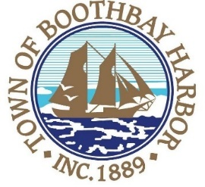
TOWN OF BOOTHBAY HARBOR
SELECTMEN’S MEETING AGENDA
Monday, September 28, 2020
Boothbay Harbor Town Office, 11 Howard Street
7:00 p.m.
Due to limited space in the meeting room to meet COVI9-19 guidelines for safety, we are also providing a Zoom meeting id and number to call for audio purposes:
https://us02web.zoom.us/j/87408447348
MEETING ID: 874 0844 7348 TELEPHONE NUMBER: 1-929-205-6099

CALL TO ORDER:
- Pledge of Allegiance
- Introduction of Town Manager & Board of Selectmen
- Town Manager Announcement(s)
- Town Department Reports
- Selectmen Reports
- Financials
- Minutes Approval – September 14, 2020
- Licenses
- New Business
  - Tom Churchill, Planning Board Chair, recommendations from Planning Board
  - Public Hearing-Adopt the Maine Municipal Association’s new (October 1, 2020-September 30, 2021) “General Assistance Ordinance Appendix” (A-D)
- Old Business
  - Footbridge discussion
  - Fireworks (Boothbay Lights Signature Event?)
  - Atlantic Avenue sidewalk notice discussion
  - Covid-19 discussion
- Public Forum
- Warrants
- Executive Session
- Motion to Adjourn

