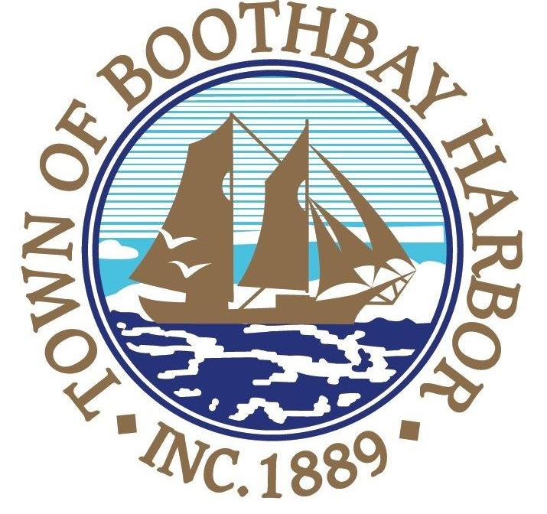

Deputy Harbor Master
Town of Boothbay Harbor

The Town of Boothbay Harbor is seeking applications for the position of Deputy Harbor Master. Qualified applicants will possess a high school diploma or GED, have a marine oriented background and an understanding of law enforcement issues. Applicants are required to have excellent public relations skills, strong work ethics, and the ability to work autonomously and make independent decisions. Training will be provided. Assisting the Harbor Master and operating the pump-out boat are the primary job requirements. Also, “rules of the road” knowledge is required. This is a part-time position where hours are worked between June and October. Compensation will be discussed with finalists.

Position will be open until a suitable candidate is chosen. Applications can be obtained on the town’s website at www.boothbayharbor.org or by calling the town office at 207.633.3671. All interested applicants must submit an application, cover letter and resume to:

Julia Latter, Town Manager
11 Howard Street, Boothbay Harbor, ME 04538
jlatter@boothbayharbor.org

The Town of Boothbay Harbor is an Equal Opportunity Employer. All qualified applicants will be considered for employment without regard to race/ethnicity, gender, qualified protected veteran, or disability status.

