The Town of Boothbay Harbor
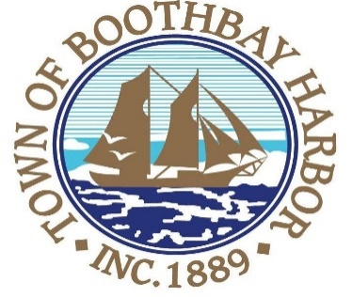
Request for Proposal

The Town of Boothbay Harbor invites qualified landscape companies to submit proposals to provide landscape work (purchase and plant) according to an established landscaping plan at the site of the Basketball/Pickleball Courts on Townsend Avenue, Boothbay Harbor, Maine. All bid packages, including vegetation site plan and plant/tree listings, are available at the town office, Monday-Friday, 8:30-4:30 p.m. Proposals are to be submitted, sealed and delivered, to Julia latter, Finance Officer, no later than 4:00 p.m. on July 26, 2019.

