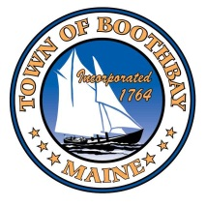
Boothbay-Boothbay Harbor
Joint Economic Development Committee Application

Name: _________________________________________________________________________________________________________________

Address: ______________________________________________________________________________________________________________

Mailing Address:_____________________________________________________________________________________________________

Number of Years Residing in Town: ______________________________________________________________________________

Town Positions Held/Previously Held:____________________________________________________________________________

Email: ________________________________________________________ Phone: ________________________________________________

Please describe your interest in serving on this committee:
___________________________________________________________________________________________________________________________________________________________________________________________________________________________________________________________________________________________________________________________________________________________________________

Please provide any background information that would be of interest to the Town when considering your application, including previous service or other relevant experience.
______________________________________________________________________________________________________________________________________________________________________________________________________________________________________________________________________________

Are you aware of any conflicts that may arise, affecting your service on this committee?

__________________________________________________________________________________________

Are you able to commit to regular attendance? Yes No

After submitting this application for appointment:
- The application will be reviewed by the Board of Selectmen and you may be scheduled for an interview.
- Following the interview, the Selectmen will vote on your potential.
- If appointed, you will receive a letter from the Town Manager and will be required to complete paperwork with the Town Clerk prior to the start of your service on the committee or board.

Signature: _____________________________________________________ Date: _______________________

Please submit to the appropriate town office.

