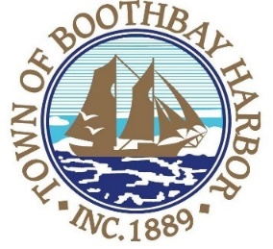
TOWN OF BOOTHBAY HARBOR
SELECTMEN’S MEETING AGENDA
Monday, January 11, 2021
VIRTUAL MEETING (VIA ZOOM): See instructions to connect below
Boothbay Harbor Town Office, 11 Howard Street
7:00 p.m.
CALL TO ORDER:
- Introduction of Town Manager & Board of Selectmen
- Town Manager Announcement(s)
- Town Department Reports
- Selectmen Reports
- Financials
- Minutes Approval – December 28, 2020
- Licenses
  - Liquor License, Malt, Spirituous & Vinous, Ports Pizzeria, 28 Union Street, renewal
- New Business
  - Wharves and Weirs Hearing held on-site at 3:00 p.m. for Boothbay Region Maritime Foundation, represented by Gartley and Dorsky Engineering and Surveying, Map #16 Lots #21 and 22, 85 and 87 Atlantic Ave., Boothbay Harbor, is proposing to remove the existing pile supported wharf and pier, and associated floats, reconstruct an existing seawall, construct a new pile supported wharf and pier, install a 3,000 square foot bait storage building, and lobster tank building. The pier repairs include the removal of a total of 450 existing timber piles and install a total of 314 new pilings. The applicant also proposes to install a new float system off the north face of the pier consisting of : (1) eight-foot wide by eight-foot long float; (23) eight-foot wide by 24-foot long floats; (9) six-foot wide by 24-foot long floats; (6) six-foot wide by 16-foot long floats; and (2) 12-foot wide by 24-foot long floats., in the waters of Boothbay Harbor, Maine.
  - Gary Stone, First National Wealth Management
- Old Business
  - Covid-19 discussion
- Public Forum
- Warrants
- Executive Session
- Motion to Adjourn
Connecting by computer: You may be required to download the Zoom app in order to connect. This is free, and easy to use. Make sure to log in a few minutes early to ensure you can connect.
Using your computer, go to: https://us02web.zoom.us/j/85434546134 Meeting ID: 854 3454 6134
Connecting by phone:
- Public participants can use their mobile phones using the number below: (929) 205-6099, meeting id (85434546134#). If you are using a regular phone, please dial the phone number (929) 205-6009, and you will be asked to enter the Meeting ID number (85434546134) followed by the # sign.
PLEASE REMEMBER TO ENABLE AUDIO TO LISTEN TO THE MEETING

