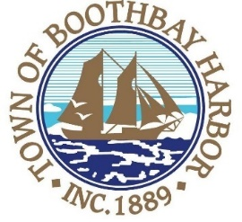
TOWN OF BOOTHBAY HARBOR
SELECTMEN’S MEETING
Monday, November 23, 2020
Boothbay Harbor Town Office, 11 Howard Street
7:00 p.m.
Due to limited space in the meeting room to meet COVI9-19 guidelines for safety, we are also providing a Zoom meeting id and number to call for audio purposes:
https://us02web.zoom.us/j/85069724525
MEETING ID: 850 6972 4525 TELEPHONE NUMBER: 1-929-205-6099

CALL TO ORDER:
- Pledge of Allegiance
- Introduction of Town Manager & Board of Selectmen
- Town Manager Announcement(s)
- Town Department Reports
- Selectmen Reports
- Financials
- Minutes Approval – November 9, 2020
- Licenses
  - Liquor License, Malt & Vinous, Russell House Bed & Breakfast, 350 Townsend Avenue, renewal
- New Business
  - Wharves and Weirs Hearing was held on-site at 3:00 p.m. Todd and Alison Prawer, represented by Atlantic Environmental LLC, 260 Samoset Rd., Tax Map 28 Lot 4, proposes to construct a four foot wide by ten foot long landing that connects to a four foot wide by eight foot long set of stairs. The stairs will connect to a six foot wide by one hundred foot long pier that will connect to a three foot wide by forty foot long ramp and a twelve foot wide by forty foot long seasonal float. In addition, the applicant proposes to connect a four foot wide by forty foot long seasonal finger float from the main float for additional docking, in the waters of Boothbay Harbor, Maine.
- Old Business
  - Covid-19 discussion
- Public Forum
- Warrants
- Executive Session
  - Executive Session under MRSA Title 1, Chapter 13, § 405 6 (C), Discussion of Real Property
  - Executive Session under MRSA Title 1, Chapter 13, § 405 6 (D), Labor Contracts
- Motion to Adjourn

