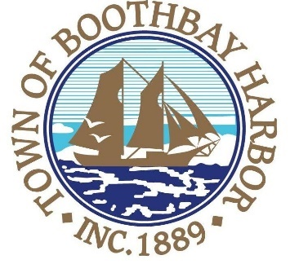
TOWN OF BOOTHBAY HARBOR
SELECTMEN’S MEETING AGENDA
Monday, August 10, 2020
Boothbay Harbor Town Office, 11 Howard Street

7:00 p.m.
Due to limited space in the meeting room to meet COVI9-19 guidelines for safety, we are also providing a Zoom meeting id and number to call for audio purposes: https://us02web.zoom.us/j/88463282988
MEETING ID: 884 6328 2988 TELEPHONE NUMBER: 1-929-205-6099

CALL TO ORDER:

- Pledge of Allegiance
- Introduction of Town Manager & Board of Selectmen
- Town Manager Announcement(s)
- Town Department Reports
- Selectmen Reports
- Financials
- Minutes Approval – July 27, 2020
- Licenses
  - Victualer License, Footbridge Brewery LLC, 25 Granary Way, new.
  - Liquor License, Malt & Vinous, Footbridge Brewery, 25 Granary Way, new.
- New Business
  - Wharves and Weirs Hearing, Kathleen A H Chapman, represented by Stockwell Environmental Consulting Inc., Map #5, Lot #6, 12 Pinkham Cove Rd., proposing to construct a 82’ x 6’ pier, a 3’ x 40’ runway, and a 10’ x 30’ float, in the waters of Boothbay Harbor, Maine.
- Old Business
  - Covid-19 discussion
  - American Cruise Lines
- Public Forum
- Warrants
- Executive Session
- Motion to Adjourn

