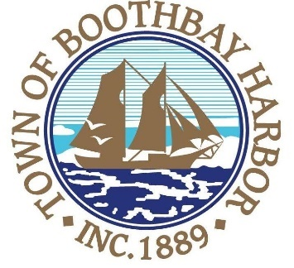

TOWN OF BOOTHBAY HARBOR

PUBLIC NOTICE

Boothbay Harbor Town Manager, Julia Latter, has announced that there are two openings on the Boothbay Harbor Budget Committee.
Applications for appointment are available by calling (207) 633-3671 to request one or on the town website at www.boothbayharbor.org.
The Budget Committee meets weekly between the months of January and March, in preparation for the annual budget to be presented at the Annual Town Meeting each May. It is a seven-member committee.

