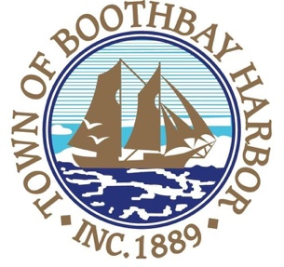

Winter Seasonal Public Works Position

Town of Boothbay Harbor

The Town of Boothbay Harbor is seeking a part-time, per-diem sidewalk plow operator/laborer.

Applicants must have a high school diploma or GED and a current driver’s license. Applicants must have a working knowledge of equipment and vehicles used in the performance of duties, ability to pass a pre-employment physical and drug test. Applicants need to demonstrate the ability to follow directions, work independently, as well as work well with contractors, municipal employees and the general public. The applicant must have a clean driving record with no accident or moving violation convictions for the preceding three years. The position includes, but is not limited to, operating plow trucks, loaders and hand equipment. Applicants must be able and willing to work beyond normal business hours.

Applications are available at the town office or online at www.boothbayharbor.org.

Applications are to be submitted to Julia E. Latter, Town Manager, 11 Howard Street, Boothbay Harbor, ME 04538 during office hours Monday through Friday 8:30 am to 4:30 pm., or by submitting it to jlatter@boothbayharbor.org. Application(s) deadline is Thursday, December 17, 2020, by 4:00 p.m.

The Town of Boothbay Harbor is an Equal Opportunity Employer. All qualified applicants will be considered for employment without regard to race/ethnicity, gender, qualified protected veteran or disability.

